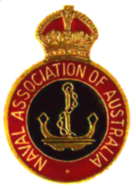 April – May, 2015
Naval Association of Australia
Heidelberg Subsection

President Secretary
Russ Allan Noel Sanderson
Email: russon@alphalink.com.au Email: weapons2@tpg.com.au
Phone: 03 9455 2002 (h) Phone: 03 9827 1467
Mobile: 0417 519 514 Mobile: 0405 467 776

Newsletter Editor/PR Treasurer
Elizabeth Stevens Hector Hart
C/- Port Lincoln Post Office 5607 Email: vms.hector@bigpond.com
Email: historymiss2@gmail.com Mobile: 0422 139 507
Mobile: 0416 165 298
- - - - - - - - - - - - - - - - - - - - - - - - - - - - - - - - - - - - - - - - - - - - - - - - - - - - - - - - - -
Hello from Port Lincoln

Well, this years’ ANZAC activities are many, including the October Ball at Etihad Stadium near Spencer Station, hosted by the Naval Commemoration Committee. An invitation arrived by email, with a terrific poster – of course, I can’t make it, but the Port Lincoln RSL and community groups and churches are having various activities; so much from which to choose. The Dawn Service was attended by 2000 people, on the lawns near the newly renovated Memorial, under a dark sky. The City Band and PL Primary School choir provided the music at the second Service, on which the heavens opened – thank goodness for my large R.A.N. umbrella, courtesy of my dear friend RANR Bruce Bird. (How are you Bruce?)
On the Sunday, we had a Concert in the Civic Hall, with the Port Lincoln Singers and the City Band.

Vale
Speaking of ex-R.A.N. personnel, Hector has advised me that we have lost two faithful and longstanding members, in Betty Twigg, wife of Peter, and Steve Earp, special friend of Betsy King.

Betty was English, and a Navy wife, with 3 children. I don’t know very much about her, but I certainly saw her at all of the Meetings (which I attended from 1995 to 2004), and lunches. She and Peter would have celebrated their 70th wedding anniversary in January, 2016. If someone would like to contact me with more information, I would be happy to include it in the next NAA News.

Steve ‘Wyatt’ Earp was also English, and was ‘first in and last out’ as he put it, serving in the R.N. He was a LT in command of Tank Landing Craft 3053, and travelled five times to Normandy; being torpedo’d on the fifth trip by the Germans, and being caught in the magazine, by falling shell cases. I will research these TLC.

It was good to speak with Bruce Ellingsen and Betty Mitchell, for information about their friends and fellow members.

- 2 –

“The Soldier,” 1914) by Rupert Brooke (1887-1915)

As you would expect, I email the NAA-News to my family interstate, and following my article about LT Rupert Brooke, my brother David, who is a CMDR of a RAAF Cadet Unit in Brisbane, reminded me of this poem, and asked why I hadn’t used it – so now I will!

If I should die, think only this of me:  That there’s some corner of a foreign field  That is forever England. There shall be  In that rich earth a richer dust concealed;  A dust whom England bore, shaped, made aware,  Gave once, her flowers to love, her ways to roam,  A body of England’s, breathing English air,  Washed by the rivers, blest by suns of home. | And think, this heart, all evil shed away,  A pulse in the Eternal mind, no less  Gives somewhere back the thoughts by England given,  Her sights and sounds; dreams happy as her day;  And laughter, learned of friends; and gentleness,  In hearts at peace, under an English Heaven.

WWI theme at Cellar Folk Club, Port Lincoln

Members sang songs, read poems and told stories at the April gathering. I talked about music hall entertainment being in vogue in England, at this time, and patriotic songs. I sang “Keep the home fires burning” by Ivor Novello (1914), which was well-received.

H.M.A.S. Shropshire Memorial Park
An article appeared on the website of this Park in February, outlining the story of how it came to be, with the meeting of Bob Boyd and Roy Cazaly DSM in 1979, and I include a photo, for your interest. As the gathering has taken place there in the month of November, I will save the story until then.

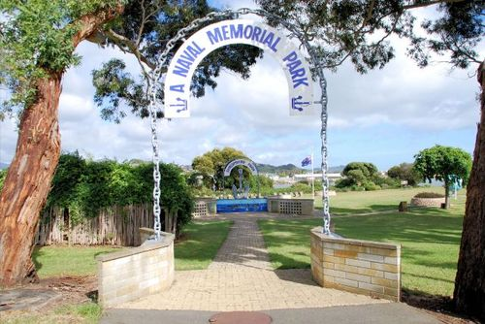
- 3 –
From Antiques Roadshow
The Certificates of William Lawson M.N. (U.K.) Master Mariner, and a message written on a ship’s biscuit, were presented on this programme, and as he travelled to Australia, I have researched this, and made a precis of the story.

Australia in the 1840’s

The perils of the sea Source: Wikipedia
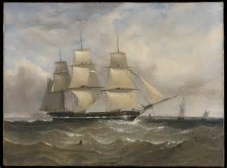  Travelling from England to Australia, still entailed many dangers and the possibility of shipwreck, although sailing time between Liverpool and Melbourne was incrementally reduced from 100 to just 64 days. The advent of the fast cutters and clipper ships improved the passenger services between England and Australia, and on the return journey, the ships carried wool cargoes. In 1845, the cutter ship America* was wrecked off the Queensland coast, with a 16-year-old Scottish girl, Barbara Thomson, being the only survivor, having been rescued by Aboriginal people of the area. One of the men believed her to be the reincarnation of his daughter Gia-Om, and she became known by that name. An Elder of the group took her as his wife, and she took part in the daily life of the people.  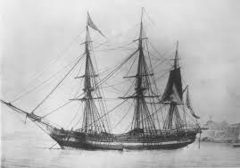 | During storms, the sailing ships were in danger of being blown onto reefs and rocks. In 1845 the Cataraqui, a migrant ship, sailed from Liverpool with about 370 people, including 73 children and a crew of about 41. One day out from Melbourne, a big storm in Bass Strait with gale-force winds and big seas, drove the ship onto reefs on the west coast of King Island. The ship broke up and water swept those who had rushed onto the deck, overboard. Eight seamen and one migrant survived, by clinging to wreckage.  Sailing and boating were the most effective means of transport over long distances, especially for travel between the colonies, and for interior expeditions. Riverboats carried passengers as well as stores, timber and agricultural produce. In 1840, the Hunter River Steam Navigation Company's ship, the Clonmel arrived in Melbourne, and was the first steamship to deliver mail from Sydney to Melbourne. Unfortunately, it was shipwrecked the following year on its second voyage, and was replaced by the iron paddle-steamer Rose. This was followed in 1841, by the H.R.S.N. Co’s vessel, which began service between Sydney, Melbourne and Launceston. Passenger ferry services in NSW, began on Sydney Harbour between Dawes Point and Blues Point in 1842.  America- Cutter. Wrecked on Entrance Island, Queensland, 1839. She was attempting to salvage whale oil from a vessel wrecked on Brampton Reef, probably the Madeira Packet, lost in 1831.
- 4 -
1915 World Events

Apr 4th - Germany protests vigorously to the U.S., claiming that it must insist that Britain lifts its blockade
and assert American neutrality.
Apr 14th - Dutch merchant Navy ship Katwijk sunk by Germany torpedo
Apr 18th - French pilot Roland Garros is shot down and glides to a landing on the German side of the lines
during WWI.
Apr 22nd - The Second Battle of Ypres begins on the Western Front
Apr 25th - First landings at Gaba Tepe and Cape Helles on the Gallipoli Peninsula
Apr 26th - Italy secretly signs Pact of London with Britain, France & Russia
Apr 27th – Counter-attack launched by Turkish forces, under the command of Mustafa Kemal Atatürk,
against allied troops.
May 1st - British liner Lusitania leaves NY for Liverpool
May 1st - German submarine sinks US ship Gulflight
May 3rd - John McCrae writes the poem "In Flanders Fields"
May 5th - German U-20 sinks Earl of Lathom
May 6th - German U-20 sinks Centurion, south-east of Ireland
May 7th - SS Lusitania sunk by German submarine; 1198 lives lost
May 8th - 41st Kentucky Derby - Joe Notter aboard horse Regret, wins in 2:05.4
May 9th - German & French fight Battle of Artois
May 10th - Zeppelin drops hundreds of bombs on Southend-on-Sea, Essex, England
May 23rd - Italy declares war on Austria-Hungary during WW I
May 24th - Thomas Edison invents telescribe to record telephone conversations
May 31st - An LZ-38 Zeppelin makes an air raid on London
Pan Am Flight Crews – a Maritime Connection
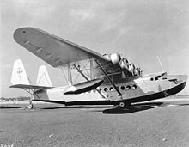  The Sikorsky S-42 was one of Pan Am's earlier flying boats, and was used to survey the San Francisco – China route.  In bad weather, pilots used dead reckoning and timed turns, making successful landings at fogged-in harbours, by landing out to sea, then taxiing the plane into port. | Many pilots had Merchant Marine certifications, radio  licenses as well as pilot certificates. Critical to Pan Am's success as an airline, was the proficiency of its flight crews, who were rigorously trained in long-distance flight, seaplane anchorage and berthing operations, over-water navigation, radio procedure, aircraft repair, and marine tides. During the day, use of the compass while judging drift from sea currents, was normal procedure - at night, all flight crews were trained to use celestial navigation.  The "Clippers" — the name hearkened back to the 19th century clipper ships, which were the only American passenger aircraft of the time, capable of intercontinental travel. To compete with ocean liners, the airline offered first-class seats on such flights, and the style of flight crews became more formal.

Instead of being leather-jacketed, silk-scarved airmail pilots, the crews of the "Clippers" wore Naval-style uniforms. They adopted a set procedure when boarding the aircraft.

The China Clipper became well known for its South Seas routings. In January 1943, Franklin D. Roosevelt became the first U.S. President to fly abroad, in the Dixie Clipper.
Editor: since researching this article on Wikipedia, I am reminded that I flew with PanAm on 08/09/1979 in the Yankee Clipper from Sydney to Hawaii, then on to Los Angeles. I don’t know how soon after this, PanAm ceased operations.
- 5 –

“Looking for King Alfred the Great” – from a programme on SBS 29/05/15
King Alfred is popularly credited as being the founder of the Royal Navy, as he did build a fleet of improved ships, manned by Frisians, and on several occasions, successfully challenged the Danes at sea.
He also tried his hand at Naval design. In 896, he ordered the construction of a small fleet, perhaps a dozen or so longships, that at 60 oars, were twice the size of Viking warships. Wessex possessed a Royal fleet before this, and King Athelstan of Kent, and Ealdorman Ealhhere had defeated a Viking fleet in 851, capturing nine ships. King Alfred himself had conducted Naval actions in 882.

The author of the Anglo-Saxon Chronicle and probably Alfred himself, regarded 897 as marking an important development in the Naval power of Wessex. He boasted that Alfred's ships were not only larger, but swifter, steadier and rode higher in the water than either Danish or Frisian ships. It is probable that, under the classical tutelage of Asser, Alfred utilised the design of Greek and Roman warships, with high sides, designed for fighting rather than for navigation.

Alfred had sea power in mind—if he could intercept raiding fleets before they landed, he could spare his kingdom from ravaging. Alfred's ships may have been superior in conception, but in practice, they proved to be too large to manoeuvre well, in the close waters of estuaries and rivers, the only places in which a Naval battle could occur.

The warships of the time were not designed to be ship killers, but troop carriers, and it has been suggested that, like sea battles in late Viking age Scandinavia, these battles may have entailed a ship coming alongside an enemy vessel, where it would lashed to the other, before boarding the enemy craft. The result was
effectively a land battle involving hand-to-hand fighting on board the two vessels.

In one recorded Naval engagement in the year 896, Alfred's new fleet of 9 ships, intercepted 6 Viking ships in the mouth of an unidentified river along the south of England. The Danes had beached half their ships, and gone inland, either to rest their rowers, or to forage for food. Alfred's ships immediately moved to block their escape to the sea. The 3 Viking ships afloat attempted to break through the English lines, and only one made it, as Alfred's ships intercepted the other two.

The one ship escaped, only because all of Alfred's heavy ships became grounded when the tide went out. What ensued was a land battle between the crews of the grounded ships, and the Danes, heavily outnumbered, would have been wiped out, if the tide had not risen. When that occurred, they rushed back to their boats, which being lighter and with shallower drafts, were freed before Alfred's ships. Helplessly, the English watched as the Vikings rowed past them.

The Royal Navy has named 1 ship and 2 shore establishments, HMS King Alfred, and one of the first ships of the American Navy was named Alfred, in his honour.
The Alfred was a man-of-war, built at Philadelphia in 1774, as Black Prince. With the British planning to send armed brigs to America, the U.S. Naval Committee purchased Black Prince on 4/11/1775, & renamed her Alfred. After 4 years service in the Continental Navy, on 9/03/1778, near Barbados, they encountered British warships, she surrendered and was taken to Barbados, where she was taken into the Royal Navy as H.M. armed ship Alfred .  Victory in Europe Day- observed by  Territories, involved in WWII | 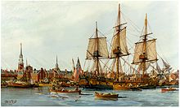  European Allied Nations and  1939 – 1945.

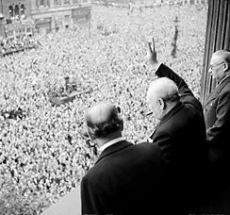  This was the public holiday celebrated on 8 May 1945 (7 May in Commonwealth realms)  at Piccadilly Circus, London. Winston Churchill waves to crowds in Whitehall, London, on the day that he broadcast the news of war with Germany being over.  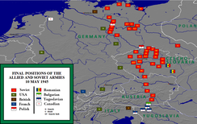  Final positions of the Allied armies, May 1945.  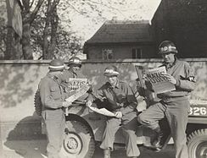 | 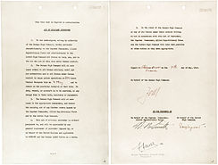  The instrument of Germany's surrender signed at Reims, France on 7 May 1945.  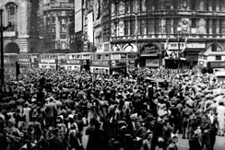  Crowds gathered in celebration at Piccadilly Circus, London, in 1945.  U.S. military policemen read about the German surrender in the newspaper Stars and Stripes.

7 –

Victory Celebrations
Upon the defeat of Germany (Italy having already surrendered), celebrations erupted throughout the world. From Moscow to Los Angeles, people celebrated, and in the United Kingdom, more than one million people celebrated in the streets to mark the end of the European part of the war. In London, crowds massed in Trafalgar Square and up The Mall to Buckingham Palace, where King George VI and Queen Elizabeth, accompanied by Prime Minister Winston Churchill, appeared on the balcony of the Palace, before the cheering crowds. Princess Elizabeth and her sister Princess Margaret were allowed to wander incognito among the crowds and take part in the celebrations.

In the United States, the victory occurred on President Harry Truman's 61st birthday. He dedicated the Victory to the memory of his predecessor, Franklin D. Roosevelt, who had died of a cerebral hemorrhage, on 12 April. Flags remained at half-mast for the remainder of the 30-day mourning period. Truman said that his only wish was "that Franklin D. Roosevelt had lived to witness this day." Later that day, Mr. Truman said that the victory made it his most enjoyable birthday. Massive celebrations also took place in Chicago, Los Angeles, Miami, and especially in New York City's Times Square.

Commemorative public holidays were put in place for European countries, involved in the War.

Soviet Victory Day
As the Soviet representative in Reims had no authority to sign the German instrument of surrender, the Soviet leadership proposed to consider Reims surrender as a "preliminary" act. The surrender ceremony was repeated in Berlin on May 8, where the instrument of surrender was signed by Supreme German Military CMDR Wilhelm Keitel, by Georgy Yukov, and Allied representatives.

Source: From Wikipedia, the free encyclopaedia

U.S.S. America – October, 2014

At San Francisco (KGO), the nation's newest amphibious assault ship, was commissioned, and will officially join the U.S. Navy's fleet.
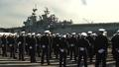
The nu-ship America is designed to maximize the Navy's capability to fly just about anywhere. It will hold more than 30 aircraft, including the MV-22 Osprey helicopter and the F-35B Fighter, both capable of vertical lifts and landings.
CPL. Mike Bowden explained the advantages of the Osprey, as being able to perform many activities that other helicopters can’t, and go twice as fast. It's also big enough to store equipment, transportable vehicles and jet fuel.
- 8 –

"We are a significant platform, with great offensive capability and can strike if required; but the peace time role for humanitarian disaster response, is pretty significant," Capt. Robert Hall Jr.
The 3000 Navy and U.S. Marine Corps will work together on the ship. The America had already travelled around Cape Horn in the southernmost part of South America, before it arrived in San Francisco. The U.S. Navy is already building another like it, called the Tripoli.

Some Australian ships which served in WWI
S.S. Maheno was a triple screw, steel turbine steamer, of 5323 tons, built at Dumbarton in 1905, for Union Steam Ship Company of New Zealand. The second turbine steamer to reach Australia, arrived in Melbourne, then Port Jackson in November, 1905. She served as a hospital ship in WWI.

SS Katoomba
Built by Harland & Wolff, Belfast. Launched 10/04/1913, and used as a passenger vessel in Melbourne. Was taken over and used as a troopship during WWI, from May, 1918. Was returned to owners in 1920.

SS Suffolk – troop ship A23 - transport for 7th Field Co. Engineers – Field Baker, Butchery 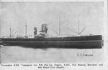 and 4th Depot Supply Unit.
HMAT A14 Euripides – troop ship – 15,050 tons – 15 knots – built by G. Thompson & Co. Ltd, London.
Commonwealth control ended on 2nd June, 1917
Source: “Don’t forget me digger.com.au”

I do hope that you enjoy this issue of the NAA News. I look forward to sharing more activities, both past and current, in the next one. Keep well, warm and happy this winter, and my thoughts are with Peter, and Betty.
Your friend and fellow member, Elizabeth

