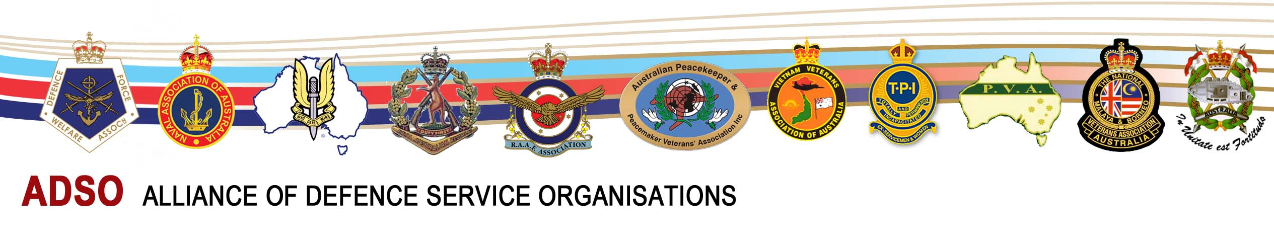

**ADSO UPDATE – 23 April 2015**

The objective of this monthly (or as required) publication is to keep you (our ADSO Members Organisations, Action Group Leaders at the State and Federal Electorate levels, Advisors and our supporters) informed on current matters that affect our objectives.

Please pass its relevant content to your member and social networks with encouragement to relay to a wider public network.

**ANZAC Day 2015**

[Pillars of Nationhood Steeped in the Anzac Legend](http://adso.org.au/latestnews/592-nation-steeped-in-the-anzac-legend)

   The Australian 23 April 2015 article by Greg Sheridan, Foreign Editor



Anzac Day is one of the supreme achievements of modern Australia. The original event in all its glory and terror rightly remains the centre of our attention: the heroism of the Anzac soldiers, the scale of the casualties in the Gallipoli campaign — 27,000 Australians killed and wounded — the role of the journalists, the galvanising effect on society, the heroism of the nurses and much, much more. ...... [More](http://adso.org.au/latestnews/592-nation-steeped-in-the-anzac-legend)

[**ADSO Flyer**](http://adso.org.au/latestnews/589-anzac-day-2015-adso-flyer)Honour the dead but fight for the Living

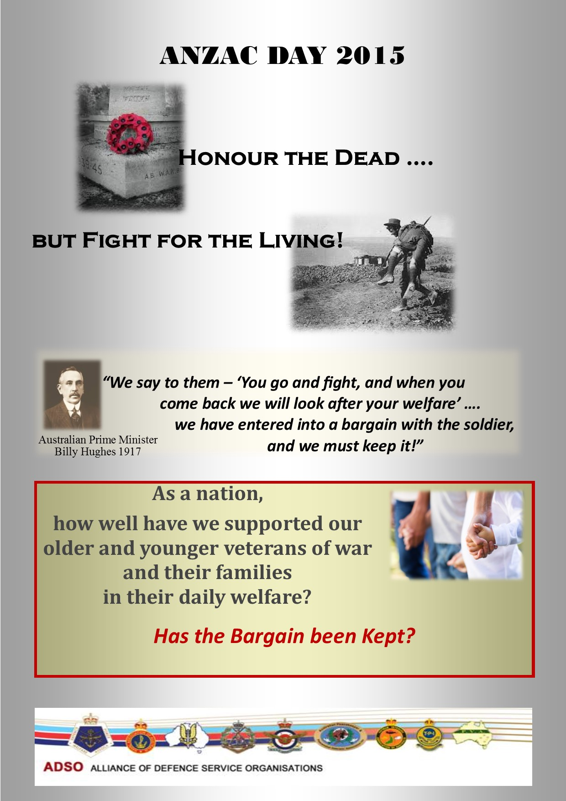

**VETERANS DISABILITY PENSIONS**

[**TPI Federation’s Letter to the PM**](http://adso.org.au/latestnews/588-tpi-federation-letter-to-the-prime-minister)

The letter raises major concerns related to the maintenance of current indexation for Veterans' Disability compensation payments and secondly, the inadequacy of compensation that is provided to our most disabled veterans Special Rate / TPI. More



[**Video – The Right Thing to Do**](http://adso.org.au/latestnews/591-video-veterans-disability-pensions-the-right-thing-to-do)



Successive Australian Governments have neglected to keep PM Billy Hughes's Bargain to veterans. It’s Time during The Centenary of ANZAC for the Australian Parliament to honour The Bargain and Do The Right Thing to restore the adequacy of the veterans' disability payments. [More](http://adso.org.au/latestnews/591-video-veterans-disability-pensions-the-right-thing-to-do)

[TPI Media Statement – Disabled Veterans Struggle to Survive on Meagre Government Compensation](http://adso.org.au/latestnews/593-tpi-media-statement-disabled-veterans-struggle-to-survive-on-meagre-government-compensation)

The TPI Federation is deeply concerned at the effect of the Government’s decision on the reduced indexation of all Veteran’s and War Widow’s disability compensation payments that was announced in the 2014 - 2015 Budget.

   
This reduction in the standard of living of those Veterans is exacerbated by the inadequacy of the economic loss component of the compensation. Whilst welfare provisions are a discretionary expenditure item on the budget, we believe compensation is a non-discretionary obligation upon the Government of the day. [More](http://adso.org.au/latestnews/593-tpi-media-statement-disabled-veterans-struggle-to-survive-on-meagre-government-compensation)

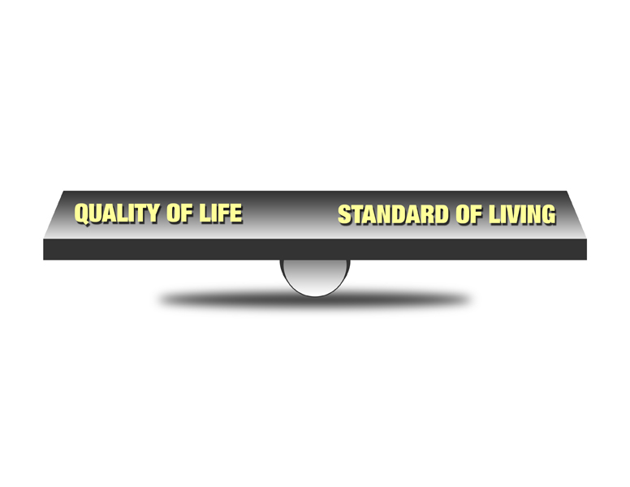

[Veterans Groups Use Anzac Centenary to Fire Up over Pension Reforms](http://adso.org.au/latestnews/8-fg-disability/586-veterans-groups-use-anzac-centenary-to-fire-up-over-pension-reforms)

Prime Minister Tony Abbott is under fire from groups representing military pensioners and war widows who say the government's proposed changes to veterans' payments threaten the quality of life and dignity in retirement of nearly 300,000 people who sacrificed for Australia.

Veterans groups have been working behind the scenes since the budget but recent meetings between the TPI Federation, DFWA and ADSO resolved to increase the pressure to coincide with Anzac Day and as Treasurer Joe Hockey finalises his second budget.

***"It's all very well to commemorate the fallen – and we support the centenary commemorations – but we have to fully support the living as well,"* said TPI National Vice-president Pat McCabe.** [More](http://adso.org.au/latestnews/8-fg-disability/586-veterans-groups-use-anzac-centenary-to-fire-up-over-pension-reforms)

PERFORMANCE – OUR RESULTS



We have been particularly successful in a number of our objectives and continue with mixed progress in others. No doubt the coming 2016 Election will create greater involvement with us from all the Parties and Independents.   
 ADSO is recognised as the Defence Family’s leading active voice to the Government, national media and the Australian public.

Our successes include:

* For past serving veterans: DFRDB Superannuation Indexation formula increased to maintain purchasing power, and protection of personal information release from The National Archives.
* For current serving ADF: restoration of tax exclusion for wounded soldiers, conditions of service improvements, restoration of Christmas leave entitlements, restoration of WRA-ADF allowances and an increased indexation of ADF pay.

Work in progress includes:

* Defending current indexation arrangements for Veterans Disability Pensions (VDP) and seeking adequate TPI/Special Rate compensation payments;
* Repeal of the Government’s intention to change the Services Pension indexation to CPI only in 2017 which also affects the VDP and War Widows’ pensions;
* DFRDB Superannuation removal of the exclusion of under aged 55 years;
* MSBS superannuation portability and an increased employer contribution;
* ADF Super Scheme - Consultation with the Government on features of the new scheme – for a higher Government contribution rate than 15.4% (The Public Service rate) to recognise the uniqueness of military service;
* Retention of experienced ADF members;
* Defence Housing;
* The Defence Force Remuneration Tribunal structure and process;
* Mental Health;
* Specialist medical services;
* Military justice;
* Reinforcing the unique nature of military service with a Military Covenant;
* Veterans ‘ Homelessness; and
* Veterans’ Care.

Thanks to all those who have contributed to this result as part of our lobby teams in Canberra and the Electorates, our State Action Group (STAG) Leaders and Local Action Group (LAG) Leaders, our Advisors and supporters.

WELCOME

We welcome to The Alliance, two new member organisations, [The Royal Australian Armoured Corps Corporation Ltd (RAAC)](http://www.raaccorpltd.org.au/) and [The National Malaya & Borneo Veterans’ Association of Australia.](http://www.nmbvaa.org.au/) We look forward to your contribution to success.

From The Fair Go Team

|  |  |  |
| --- | --- | --- |
| ‘Fair Go’ Campaign Directors Ted Chitham 0418 733 887 Alf Jaugietis 0438 282 284 | <http://www.standto.org> | ADSO National Spokesman David Jamison 0416 107 557 |